Certificate of Attendance

This is to certify that
_____________________________
has satisfactorily completed one training hour entitled:

[Insert Event Title]

[Insert Event Date]

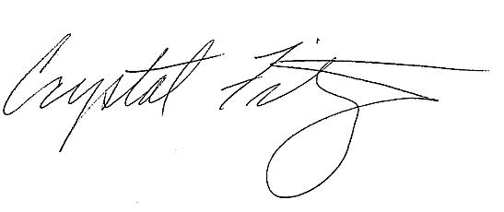
1 Credit Hour

Crystal W. FitzSimons
Food Research and Action Center

www.frac.org

