Contact:
Name
Organization
Email
Phone
SNAP Participation Lags Among Eligible Seniors in State,
Putting Them at Greater Risk of Hunger
City, State, Date — Many older adults in state who struggle against hunger are missing out on a critical program to help put food on the table, according to interactive data tools produced by the Food Research & Action Center (FRAC), with support from AARP Foundation. The Supplemental Nutrition Assistance Program (SNAP) helps low-income seniors afford the food they need for their health and well-being, yet the FRAC map illustrates how just X percent of eligible seniors (60+) in state are using SNAP on average each month.
“These maps show that far too many of state’s seniors are missing out on the health and nutrition benefits that SNAP provides,” said spokesperson, title, organization. “Having reliable access to enough food is important for everyone, but it is particularly important as people age and become more vulnerable to illness, or when their life circumstances — such as limited mobility or a fixed income — make maintaining a healthy diet more difficult.”
In addition to staving off hunger, SNAP helps decrease the risk hunger-related health problems, such as diabetes, hypertension, and depression. Many seniors may not be aware that they may be eligible for SNAP, or may feel stigma about receiving food assistance.
Participation rates among eligible seniors vary across the nation, but all states, including state, have substantial room to grow SNAP participation among seniors. With X percent of eligible seniors participating, state is in the middle/high-performing/low-performing in comparison to other states. At 70 percent, New York leads the nation in SNAP participation among eligible seniors, while California and Wyoming ranked as the two worst performing states, with participation rates among eligible seniors at 19 percent and 20 percent, respectively.
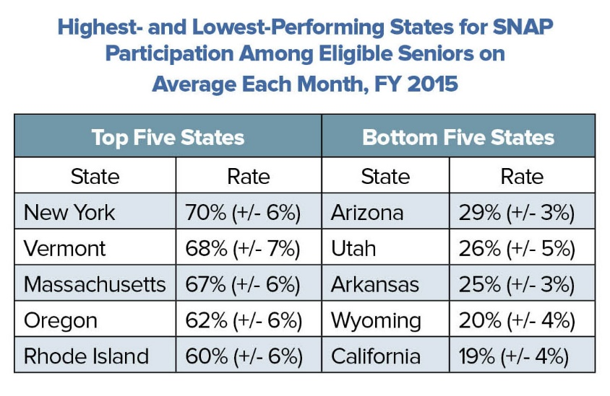
To close the senior SNAP participation gap, health care providers, social service agencies, and nonprofit organizations in communities across state can adopt and promote available best practices to reach many more seniors with information about the availability and benefits of SNAP. Health providers can screen patients for food insecurity and refer seniors to SNAP as a treatment resource, as laid out in the FRAC/AARP Foundation’s free online course, Screen & Intervene: Addressing Food Insecurity Among Older Adults.
“Food-insecure seniors often must choose between paying for food or medication,” added spokesperson, title, organization. “SNAP helps ensure that seniors do not have to cut back on or skip meals altogether to pay for health care or other basic needs.”
# # #
About Organization
Insert boilerplate language about your organization.
About the Food Research & Action Center
The Food Research & Action Center is the leading national nonprofit organization working to eradicate poverty-related hunger and undernutrition in the United States. Visit frac.org to learn more.

